Painted Cubes

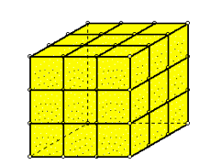
PART A: A white 3x3x3 cube is built using smaller 1x1x1 cubes. If this big cube is dipped in yellow paint, then taken apart into small cubes again, how many of the original, individual cubes will have…

- NO sides painted yellow?

- ONE side painted yellow?

- TWO sides painted yellow?

- THREE sides painted yellow?

- More than three sides painted yellow?

PART B: Come up with a rule for knowing how many individual cubes are painted in some way in an NxNxN cube. Your rule should help someone predict how many cubes will have 0 sides painted, 1 side painted, 2 sides painted, 3 sides painted and more than 3 sides painted.

